2020 AAHA Virtual Management Training

October 20, 21 & 22, 2020

Training By: Gary Kirkman, HCCP, FHC
Director of Compliance Training
E&A Teams, Inc.

October 20 - Fair Housing for Manager & Maintenance 10am-12pm & 2pm-4pm
Fair Housing Topics:
Federally Protected Classes
Prohibited Acts
Reasonable Accommodations/Modifications
Fair Housing Statistics
Statute of Limitations & Code Enforcement

October 21 – LIHTC 10am-12pm & 2pm-4pm
LIHTC Topics:
Student Eligibility
Determining Annual Income
Determining Asset Income

October 22 - RD Training 10am-2pm & 2pm-4pm
RD Topics:
Student Eligibility
Determining Annual Income
Determining Asset Income

Each course is $200 per person.
For every 4 attendees registered, the 5th registration will be FREE. *
*To obtain complimentary registration(s) awarded for every 4 attendees registered, registrations and payment must BOTH be received by October 1st for the 5th attendee to be free.

Email Address for Each Attendee: The email address provided for each attendee in the excel sheet will be used to access the virtual training meeting. Training materials to be downloaded will be sent to this email address a few days prior to training date.

Excel Sheet Attached:
Please be prepared to upload the completed excel sheet attached to this email with the information of the attendee(s) you are registering during the completion of your registration.

Please refer to the picture to see how to select the Training Course(s) you would like to register each attendee for using the dropdown arrow. The excel sheet is set up to automatically calculate the total for each attendee and will provide at sum total at the bottom.

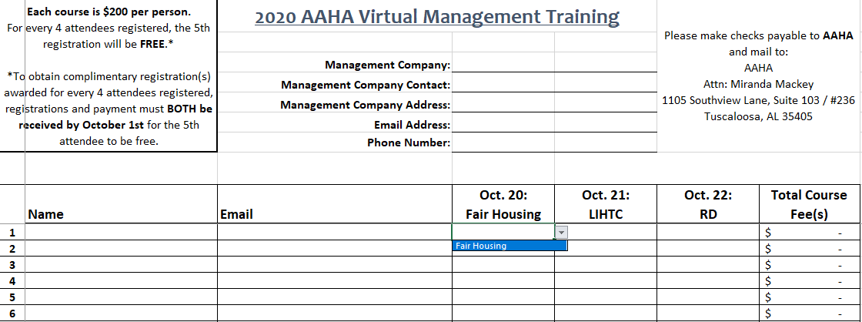

After we receive your completed registration list (excel sheet), we will promptly email you back an invoice with the adjusted total to reflect the complimentary registrations.
  - To obtain complimentary registration(s) awarded for every 4 attendees registered, registrations and payment must BOTH be received by October 1st for the 5th attendee to be free.

Please make checks payable to AAHA and mail to:
Alabama Affordable Housing Association
Attn: Miranda Mackey
1105 Southview Lane, Suite 103 / #236
Tuscaloosa, AL 35405

